
A Guide to the

60-Minute Toolkit for Emergency Readiness


for Election Officials

This guide is meant to be a companion to the 60-Minute Toolkit for Emergency Readiness, which you can find at electionsgroup.com/readiness.

We encourage you to have the Toolkit file open as you read this guide and work through its exercises.

The guide will ask you to make changes in the Toolkit. The exercises are designed to help you build the Toolkit out to use as your Continuity of Operations or Emergency Readiness plan.

Making changes directly in the file will help prepare that file for use in an actual emergency.

Introduction
Election officials are resilient. We routinely face late-breaking, urgent situations. Poll workers cancel and polling places back out at the last minute. Judges order changes after ballots are printed and machines programmed.

A Standard for Readiness

Your office is prepared to address emergencies that may disrupt administrative or voting functions.

Source: U.S. Alliance “Standards for Election Excellence”
This guide gives you tools to strengthen your resilience, even in a large-scale crisis, by simplifying the chaos into a manageable set of problems.
This guide is for anyone who hasn’t written out their emergency response plan, whether you have it in your head, or you haven’t started.
The outcome this guide offers is that when facing a large-scale crisis, your response is coordinated and moving. Within 60 minutes, you can:
- Assess scope and impact across the functional areas of your office
- Assemble core team members to discuss and direct the response.
- Give assignments to core team and notify support team members.
- Everyone involved knows their role and is moving to restore critical functions.
You will design the blueprint of your response with tools from the “Emergency Readiness Toolkit”. The goal of this guide is to help you:
- Understand the tools
- Adapt them to the unique needs of your office

Tools in the Emergency Readiness Toolkit
Incident Assessment Checklist – sorts the chaos into discrete functions affected
The Election Emergency Core Team – your go-to people to manage a crisis
Restoring Function Checklists – steps for recovery in each area of your office
The Emergency Support Team – contacts whose specialties may be needed
A Backup Resources list – provides location & source or identifies unmet need
By understanding and adapting these tools, you’ll be ready when a crisis hits.

Finally, this guide recognizes that 60 minutes is only enough to establish basic readiness. Many of you will still need to fill in details. We’ll help you create:
- A Readiness Agenda with future steps to ensure full readiness
- A Review Calendar for practicing, testing and revising the plan

Understanding the Tools – A Summary:
The 60-minute toolkit is a set of document templates. You will complete them, adapting sections and filling in contacts and resources. They become your emergency plan.

Please have the 60-Minute Toolkit file open while you continue through this Guide.

The guide is meant to help you build the Toolkit into a functioning Continuity of Operations / Emergency Readiness plan.

Making changes in the Toolkit will mean your updates are included when you need to use the tools in an actual emergency.

Please look at the tools in your Toolkit file as we describe them:

1) The Crisis Response Timeline
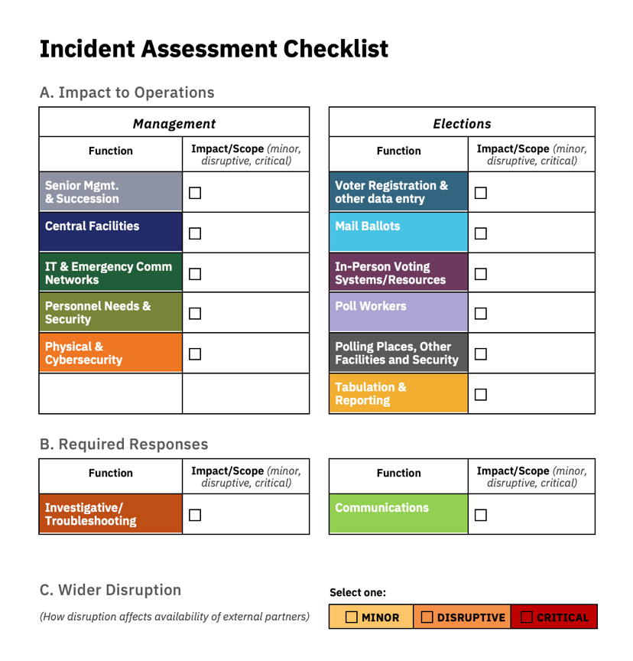
This is a simple checklist to remind you of the phases of your response – Assess, Assemble, Assign, Restore and Review.

2) The Incident Assessment Checklist
The Incident Assessment Checklist is meant to help you sort out the impact of an incident. This tool prompts you to consider every functional area of your office, ensuring smaller impacts aren’t lost in the chaos.
The checklist helps you structure your response. You will check off each function affected and rate the degree of damage. The checkmarks point you to Restoration of Function checklists (see #4 below) for each area of your office.
As head of the office, you will use this chart to create your initial assessment, even as you assemble your team. Then, you’ll go over your assessment with the team to confirm your initial reaction.

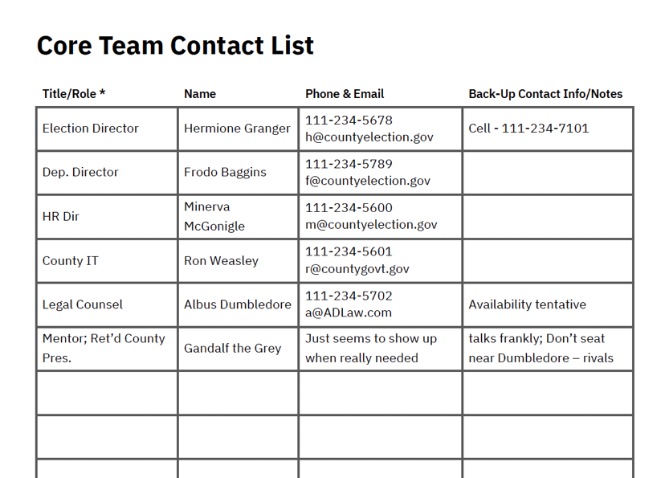
3) The Core Team Contact list
The Core Team is the group you want around you in a crisis, a team with the knowledge, leadership skills and organizational talents to get you back in business quickly.
These are people you trust, including to tell you bad news when necessary.
You likely already have them keyed into your phone, but thinking through who is on your Core Team ahead of time will ensure you have everyone and get them assembled quickly.

4) Restoration of Function checklists
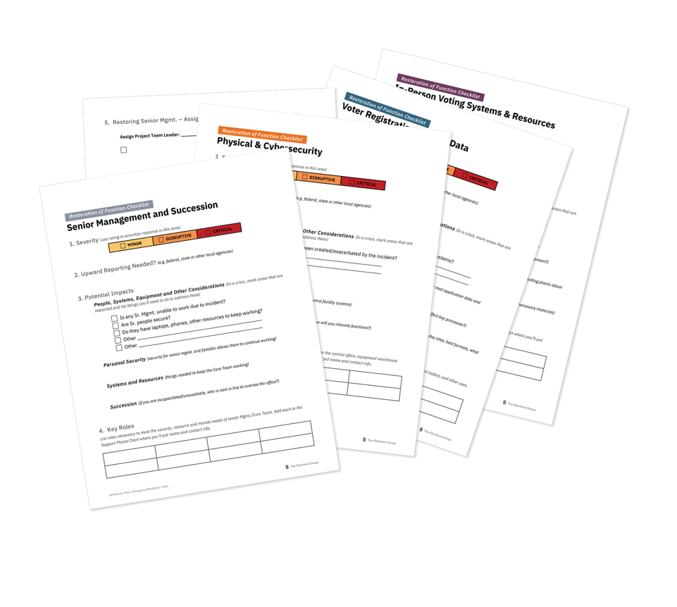
The thirteen Restoration of Function checklists are the heart of this approach to Incident Management. Linked to the categories from the Incident Assessment (Tool #2), they present people, resources, alternative options and ideas necessary to restore operations in each area of your office.
The front of each RoF checklist is something you build out during the planning phase. During an incident, you’ll pull out the relevant checklists (those for areas you marked as impacted when you completed Incident Assessment), and use the blank area on the back of the form to assign tasks and set times for completion.

5) Support Team Contact list
The Support Team is everyone who might help get you back up and running – partner agencies, vendor staff, election staff not part of your core team. Everyone from the voting equipment company’s repair person to the pizza place where you’ve arranged a deal when staff have to work late.

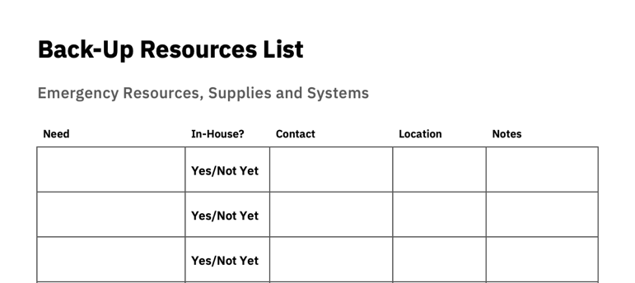
6) Backup Resources list
The backup resources list is a place to list resources you have and resources that support partners can provide. But not only those. It’s also the place to note resources you wish you had and need to work on.

Adapting the Tools to Make Them Work for Your Office
The goal of this Guide is to lead you through exercises that help you customize the tools so they work for your office. You’ll work through some exercises that help you:
- Flesh out a Restoration of Function checklist for each area of your office with
    - Equipment and systems that may need to be moved, backed up or restored.
    - Important considerations that should guide your response
    - Reminders of fallback options you might not remember at the moment of a crisis
- Fill in contact names for the Core Team and Support Team
- Brainstorm necessary resources and fill them in on the Backup Resources list.

Using the Toolkit
Once you’ve customized the tools for your jurisdiction, the toolkit becomes your emergency response plan. You’ll pull the package from a file at a moment of crisis, and it will help you organize a coherent and complete response.

Assess, Assemble, Assign, Restore and Review
It may be helpful to think of five stages of emergency response – Assess, Assemble, Assign, Restore and Review. These stages will overlap across time and you’ll double back to repeat them. It’s still helpful to think of them as separate steps, since each has its own considerations and must be completed.

1) Assess
As chief election official, you will use the Incident Assessment Checklist to consider each area of the office and how functions may be interrupted or impacted. This initial assessment helps you set aside the anxiety of a difficult moment and focus on the work that will need to be done.

2) Assemble
Call your Core Team together using the Contact List. Whether in person or on by video conference, review your initial assessment with the Core Team. These are people you trust, and they may recognize impacts you’ve overlooked.
For every box you check on the Incident Assessment Checklist, pull out the corresponding Restoration of Function (RoF) checklist. Review these checklists with the team. Use the reverse side of the RoF checklist to record tasks that will need to be completed.

3) Assign
Assign someone from the Team to track each area of the office that will need attention. Go over the RoF checklists with the whole team, considering whether the remedies you’ve sketched out in planning sessions will still work, or whether the incident has also affected your fallback options.
In a small office, you may foresee that many of these tasks will fall to you. That’s okay. The Core Team still provides fresh perspectives and ideas to consider. And emotional support in a difficult moment. Their presence will keep you focused.

4) Restore
The Restoration of Function checklists, once you’ve customized them, provide contacts, resources and steps you can follow to address issues in each area of your office. LIst all tasks on the reverse side of the checklist, assign each task to someone on the Core or Support team and set a deadline for completing it.
Use the Support Team Contact list and the Backup Resources list to bring in the help you need.

5) Review
Before you let the Core Team go, set a time to come back together in person or by video conference to review progress. Use the tasks listed on the Restoration of Function checklists to ensure you’ve addressed every issue.

Flowchart – Incident Assessment and Response

Assess, Assemble, Assign, Restore & Review
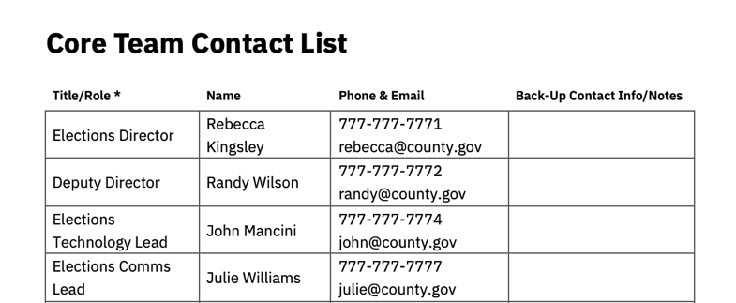
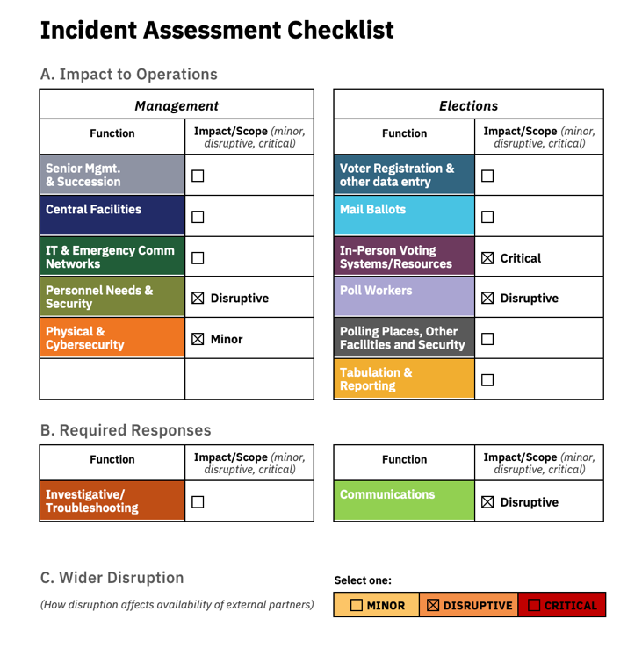

Assemble Core Team Immediately

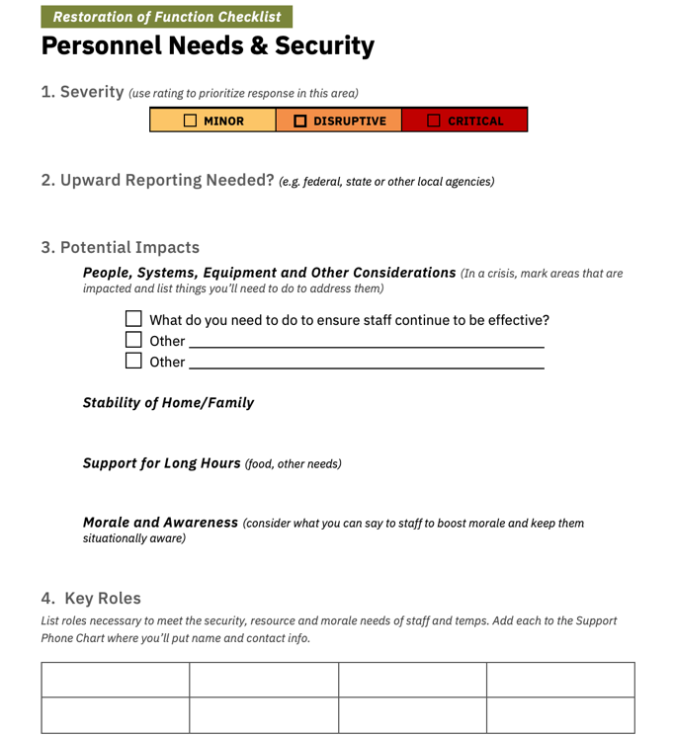

Go to the checklist for each function impacted

The chart reminds you to assess impact across the whole office

The function checklist helps create your call list to launch response

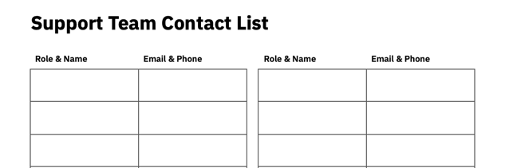

Each Restoration of Function checklist reminds you of key steps to ensure continuity of function

Incident Response:
- Use the Incident Assessment Checklist to determine what parts of your office are impacted and gauge the severity of the incident.
- Activate a Core Team, your trusted circle, to help manage your response.
- Working with the Core Team, consult the Restoration of Function checklists for each function affected to manage your response.
- Use the Support Team contact chart to notify partners and restore operations.
- Use the Backup Resources list to call in resources you’ve pre-identified.

I | Incident Assessment with the Checklist:

A. Framework for Assessing an Election Crisis:
This section will talk about:
- Functional Impact - determining which office functions are impacted and how great the disruption is the most important assessment step before launching a full response
- Wider Community Disruption – impacts on your wider community will
- The Incident Assessment Checklist – an analysis tool that helps you sort out impact and directs you to steps you’ll take to respond and restore operations.

Functional Disruption
In our conception, the very first measurement of an incident to consider is functional disruption. Which functions of your office are affected, and what is the scope of the disruption? This more than the type of incident determines your response – what you need to do to keep the office running.

Senior Mgmt. & Succession

Central Facilities

IT & Emergency Comm Networks

Personnel Needs & Security

Physical & Cybersecurity

Voter Registration & Other Data

Mail Ballots

In-person Voting Systems & Resources

Poll Workers

Polling Places & Other Facilities

Tabulation & Reporting

Investigative

Communications
Organizing Crisis Response Around Office Functions

We use this list of operational functions throughout the guide as a key tool organizing crisis response. Yet we recognize that functions bleed over into other functions, and that your office may be organized differently. Edit the list as needed to make it work for your office.

Wider Community Disruption
In a major crisis, a tornado, hurricane, wildfire or a security threat that impacts multiple neighborhoods and workplaces, the disruption for the wider community will affect the capacity of your external partners and even your own staff to respond to the election crisis.
Emergency responders may be forced to prioritize other community assets. Utility and internet providers will be drawn in multiple directions. Community disruption can have such a major impact on your crisis response that it is factored into our resources.
We include space to note Community Disruption in our Incident Assessment Checklist because it can affect your partners, and therefore how you respond to an incident.

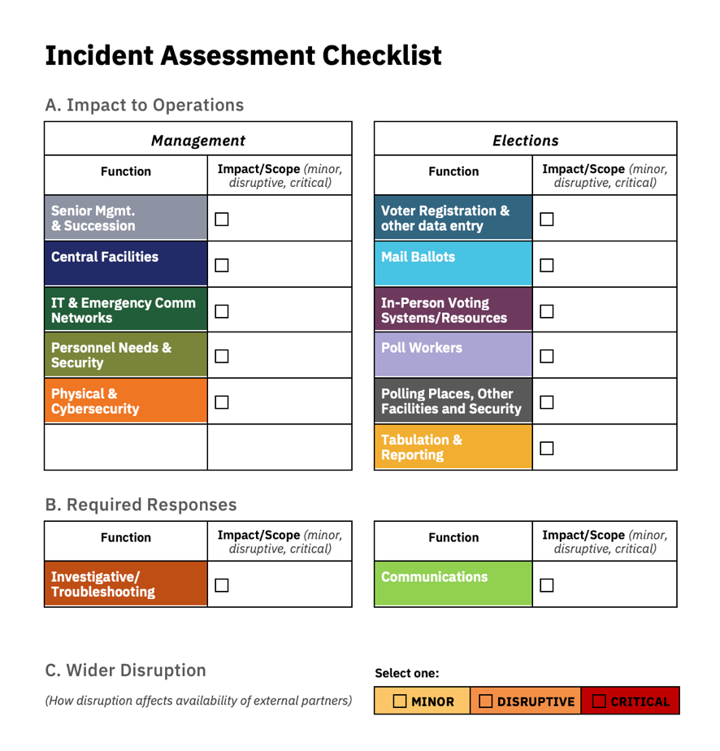
Incident Assessment Using the Checklist
By asking you to evaluate the situation on the basis of the parts of your office affected, the checklist ensures that all impacts are recorded and handled.
We’ve chosen categories that we believe reflect a full cross-section of activities and operations in your office - both management / back-office operations like those on the left side of the checklist, and functions directly related to the conduct of the election like those on the right side.
This checklist helps you make a full, accurate assessment and get the response started.
Each category and checkbox leads you to a Restoration of Function checklist (see below), which provides a detailed guide to handling issues in that area.

Other Fields in the Incident Assessment Checklist
Look closely at section B of the checklist. Unlike section A, where you’re assessing the impact of the incident on areas of your office, in section B, you’re gauging whether you need to activate other types of response.
The Investigative / Troubleshooting box reminds you that in some situations, you may not know the full impact or even what is causing the problem. In a recent midterm election, one large jurisdiction found that ballot scanners were rejecting many ballots, even though many other ballots continued to scan properly. Even as they began to respond in ways to ease lines at scanners and ensure voting continued, they had to launch a troubleshooting investigation to determine what was causing the issue.
The Communications checkbox is there to remind you to provide public information as necessary, reassuring the public and letting them know of any changes in where they need to go to vote, how they will vote and what you are doing to ensure their vote will be counted.
These two “Required Response” checkboxes lead to Restoration of Function checklists for Troubleshooting and for Communications, just as the IT and Mail Ballot checkboxes do. That is where you’ll develop your plan for those areas (during the exercise) and where you’ll find the plan when a difficult situation emerges.

Adapting the Checklist
Consider the categories provided. Does the set of categories fully describe your office? The list can be adapted.
If you’re in a state that primarily votes by Mail Ballot, you may want to add categories to provide greater focus on different aspects of the mail ballot process,and perhaps downgrading Polling Places and In-Person Voting Systems.
If your office handles other responsibilities than elections, you may find it useful to list them, since many potential incidents could trigger a response for the entire office.

B. Exercise: Incident Assessment
The goals of this exercise are to:
- Understand the Incident Assessment Checklist
- Adapt it to your local context
- Explain how this checklist will guide your effort to restore your office functions.

Incident Brainstorming
Take two minutes to list out as many situations disruptive to elections as you can think of – issues you’ve talked about, things you’ve read/seen in the news, security incidents, weather incidents and operational accidents.

List potential incidents:

Consider these examples. Add any that you think potentially relevant for your office.
- Natural Disasters - snow/ice, flooding, tornado/high wind damage, fire, earthquake
- Health-Related Disaster - epidemic or localized illness, illness in key office position
- Interference / Public Anger – Bomb hoax, disruptive protest, white powder, active shooter
- Technical / Election systems – Power, phone or internet outage; voting equipment failure; cyber-attack.

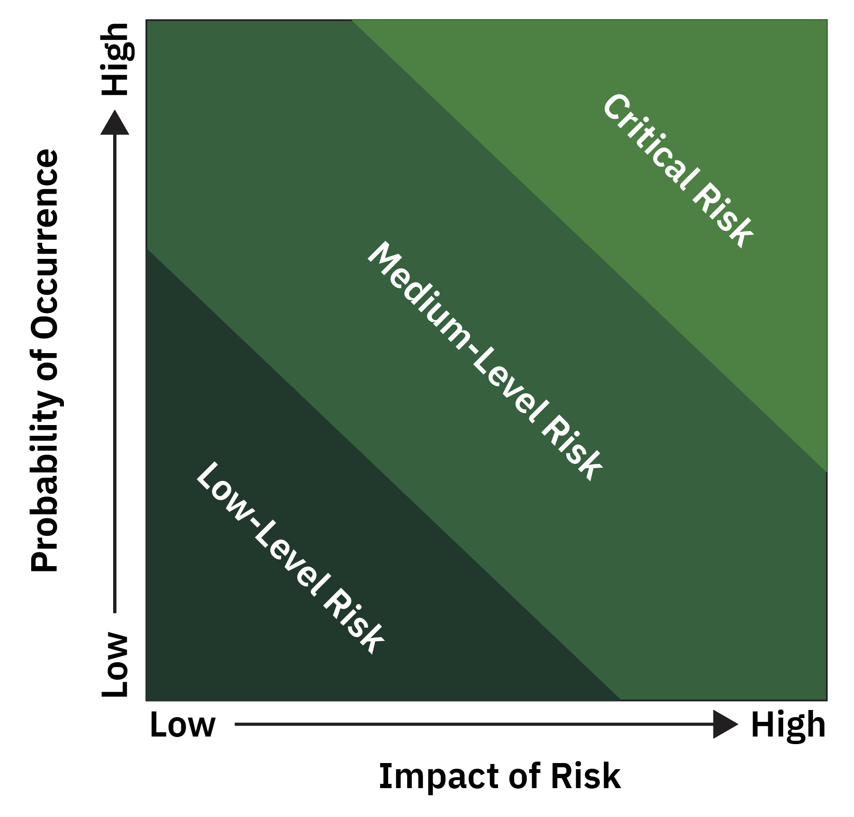
Risk, Probability and Impact
You may have reacted to some of the examples we provided by thinking “That will never happen here!” You may be correct. The diagram at right might help confirm it’s a scenario you shouldn’t worry about.
Or it might make you reconsider. An unlikely incident with a very disruptive impact may be equally important to prepare for as a likely incident with a relatively low impact.
Go back over the incidents you wrote down, and grade each with L (Low- Level Risk), M (Medium-Level) or C (Critical Risk) based on where you place them in the diagram.

The Impact of a Crisis on Office Functions
Now we’ll start to think about crises in terms of their functional impact. A crisis can affect different parts of your office to different degrees.
We’ll start by thinking about the level of severity for different functions.
Minor | Disruptive | Critical
Consider the impact of a tornado in an outlying portion of your jurisdiction, in the week before election day. You might assess that there is:
- Little or no impact on Senior management (unless someone’s home was damaged) or to central facilities or IT. Ballot preparation and voter registration are complete and ongoing data entry /list prep will be unaffected.
- Minor impact on Mail Ballots, assuming no drop box was destroyed. Some delivered ballots may have been lost in damaged homes, and voters may be calling for replacements.
- Disruptive impact on Personnel if any staff lived in the area hit. If their home is damaged, or their kids’ school has closed, you’ll need to support them, and consider when they can return to work.
  - Security / Chain of Custody should also be considered, particularly if equipment had been delivered to polling places in the area affected.
- Critical impact on Voting locations rendered unusable; Poll workers whose homes were damaged.
  - Communications will be a major concern as you work to reassure voters and explain how you plan to ensure they can vote.

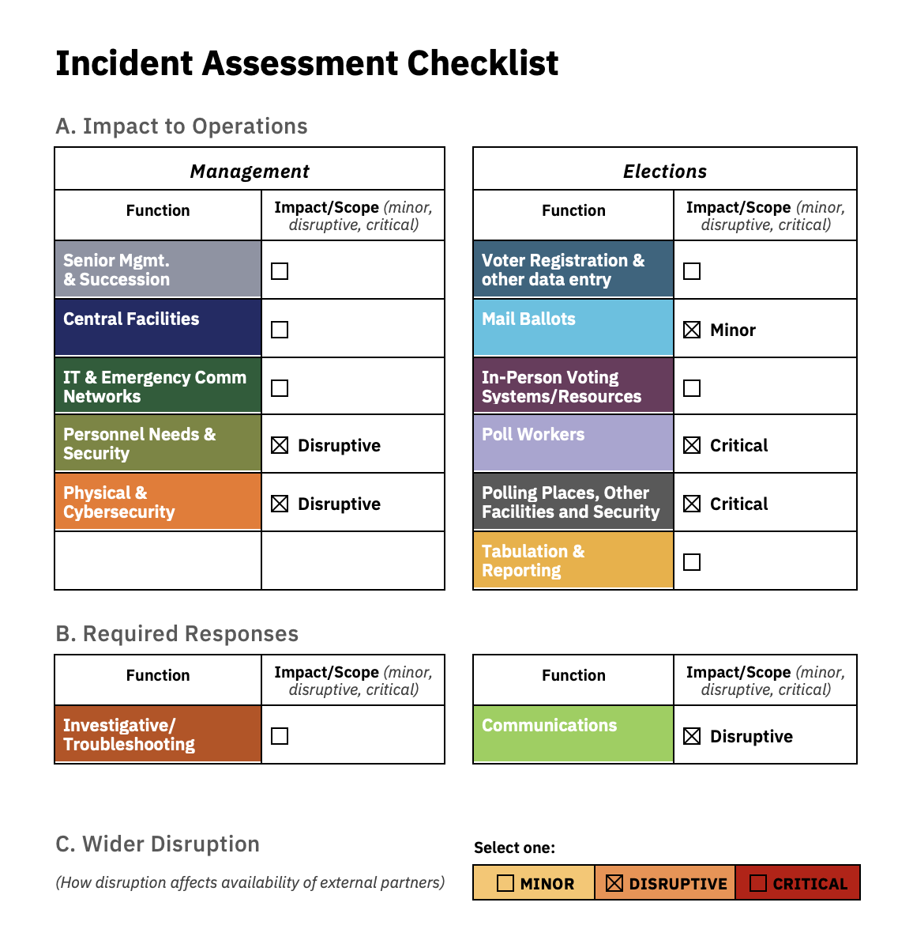
Using the Incident Assessment Checklist, that might look like this:
If you had really experienced a tornado, you would fill out the Incident Assessment checklist as above. After calling together your Core Team, you would review the checklist, asking whether anyone thinks you’ve over- or under-estimated the impact. Then you would use the results to pull Restoration of Function checklists for each area of the office where you checked off the Impact box.

Assessment of Functional Disruption
For this part of the exercise, we’d like you to select one of the incidents from the list you made, one that you rated either Medium or Critical. You will follow this incident through the exercise, using and adapting each of the tools in our Toolkit. We suggest choosing an incident that would have a broad impact on different parts of your office, since this will give you a more detailed understanding of the tools.
Write the incident here.

Incident:

- Mark up the Incident Assessment Checklist on the following page to evaluate the impact of the incident you choose.

Incident Assessment Checklist

A. Impact to Operations
Management |  |  | Elections
Function | Impact/Scope (minor, disruptive, critical) |  | Function | Impact/Scope (minor, disruptive, critical)
Senior Mgmt.  & Succession |  |  | Voter Registration & other data entry
Central Facilities |  |  | Mail Ballots
IT & Emergency Comm Networks |  |  | In-Person Voting Systems/Resources
Personnel Needs & Security |  |  | Poll Workers
Physical & Cybersecurity |  |  | Polling Places, Other Facilities and Security
 |  |  | Tabulation & Reporting

B. Required Responses
Function | Impact/Scope (minor, disruptive, critical) |  | Function | Impact/Scope (minor, disruptive, critical)
Investigative/  Troubleshooting |  |  | Communications

C. Wider Disruption | Select one:
(How disruption affects availability of external partners) | Minor | Disruptive | Critical

- Once you’ve completed the Checklist, answer these questions:
  - Did the categories allow you to record impacts across all units and functions of your office, or do you need to add or change categories?
  - Could some impacts have been placed in more than one category?
    - Maybe a backup laptop could be classed as a Voter Registration need or an IT responsibility?
    - As long as you can resolve for yourself where such issues belong, don’t worry too much about them.
  - Did the incident you worked on have a wider community impact? How would that affect the availability of partner agencies? Would it delay any needed support? Would you need to adjust your response?

- For any changes you want to make,
  - Make them in the copy of the Incident Assessment Checklist in the Toolkit.
  - That is the one you will have on file to use in an actual emergency.

Congratulations! You’ve built out the first tool for your Emergency Readiness plan, an Incident Assessment tool that will remind you to consider vulnerabilities and impacts in every area of your office if a crisis hits.

II | Activating the Initial Response
The initial response to a crisis continues the process of rapid assessment, while:
- Assembling your core team and ensuring their ability to lead restoration of election operations.
- Establishing incident command for the overall response.
- Confirming the integrity of your management team and central facility, restoring those functions on site or establishing an alternate command center.
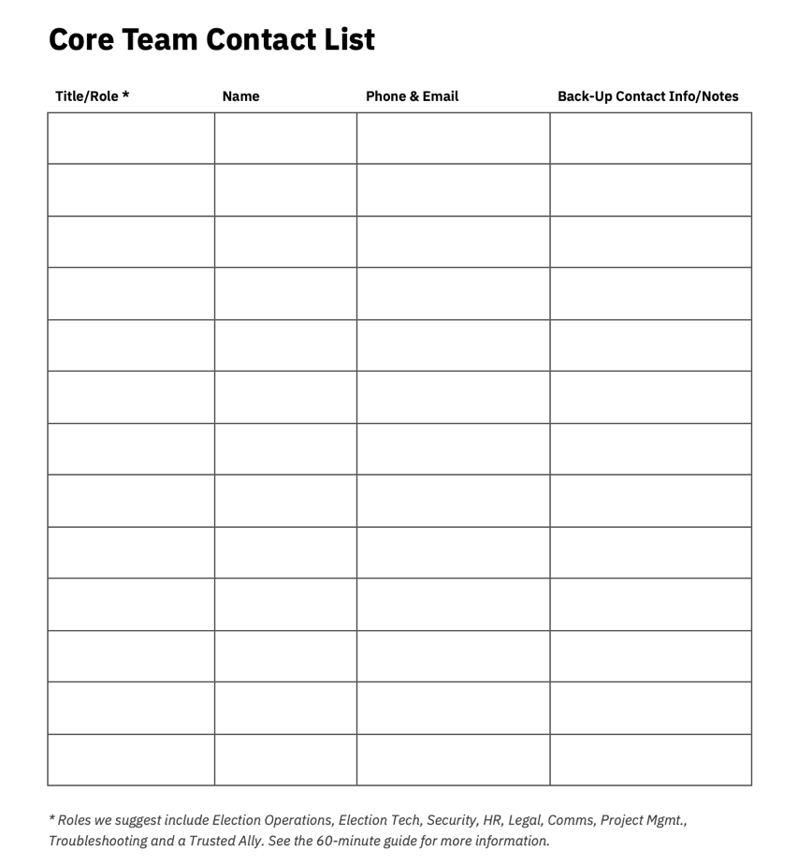
This is an urgent, immediate effort to bring a core team together and get the work of operational restoration started.

Assembling the Core Team
Your Election Emergency Core Team is the group of people you find indispensable, who you want around you as you respond to a crisis. This might be three to five people or a dozen depending on the size and composition of your office.
These are the people you’re calling first, during that initial, emergency response, assembling them to coordinate the restoration of operations. Ideally calls to your core team are going out–within minutes.
You might fill most of these roles:
- Election Operational (director, deputy director and/or key staff)
- Election Technology (IT, equipment staff and/or vendor staff)

Add your Core Team to the Contact List in the Tools file.
- Security (sheriff/police, law enforcement liaison or internal liaison to L.E.)
- Human Resources
- Legal
- Communications (internal and external)
- Project management (organizing assignments and tracking completion)
- Troubleshooting/Investigative Ability someone with curiosity and knowledge to explore problems whose causes you haven’t determined)
- Trusted ally (a mentor, previous office-holder or other trusted person outside your team, so they can speak frankly)

Exercise - Building Out Your Core Team
Take a moment to consider each of the roles described above. Think about who fills each role for your office.
- For anyone in those roles who you want on your Core Team, fill their name in on the Contact list—the copy that is in the Toolkit—so your Core Team Contact list becomes part of your permanent plan.
  - It isn’t necessary to have every role in the Core Team, which is a group for making broad decisions and helping oversee the response.
  - Others will still be included in the Support Team, and their technical knowledge will be useful in decision-making for parts of your response like IT, Personnel or In-Person Voting Systems.
Now think back to a difficult situation.
- Who did you call to your office? Who provided good advice, or let you know about something you weren’t doing but should have?
- Who is reassuring to have nearby in a difficult moment? Someone who keeps you focused? Someone who reassures you?
- Again, write down those who you want on the Core Team.
Consider the incident you chose for the previous exercise.
- For that scenario, who would you need on hand to make sure you made good decisions and followed through?
- If you want them on your Core Team, add them to the Core Team contact list in the Emergency Readiness Toolkit file, or a paper copy.
Now review your Core Team list.
- Is the Team right-sized?
  - Is there anyone whose presence might be disruptive? Move them to the Support Team?
  - Is anyone missing that would be helpful. Add them.

Congratulations! You’ve built out the second tool for your Emergency Readiness plan. You’re now ready to face a crisis with a skilled and trusted group of partners!

Meeting with the Core Team
In a crisis, you will call your Core Team together, whether by meeting, video conference or a mix. You need their wisdom and skills to address the challenges.
The first step in that meeting will be to quickly review the Incident Assessment. Your Core Team may point out issues you missed. They may suggest adjustments to your assessment of the severity of the issue in each functional area. Maybe the impact on Poll Workers is disruptive, but not critical. This may change your triage – your decisions on what to address first.
The next step will be reviewing Restoration of Function (RoF) checklists for the areas that are impacted. Hand out copies so they can review with you.
- First, focus on any management functions that have been disrupted (categories on the left side of the Incident Assessment checklist). Review the plan with the Core Team.
- Then turn to the restoration of Election Operations, the functions listed on the right side of the Incident Assessment checklist.
  - We will go into detail on these checklists below and help you build them out for your office. For now, simply recognize that you’ll want to discuss them with the Team.
- Make assignments, starting with overall responsibility for each area and its RoF checklist. Ask your Core Team to take responsibility for areas of the response they can handle.
- With them, list out step-by-step instructions with deadlines and who should be responsible. Record this on the back of each RoF checklist.
As you and your Core Team work out the response plan and assignments, you’ll need to begin activating Support Partners. They can be brought in to help design the

Establishing Incident Command
An important task of the Core Team meeting is to establish “Incident Command”. Incident command does not mean the ongoing leadership of an election office. It means the command of the response efforts related to a single incident.
If an office is experiencing a single disruption that is strictly election-related, for instance a voting system failure of some sort, then it is likely that the senior election official will hold Incident Command, making. If you have multiple balls in the air, you might seek to put someone else in charge as Incident Commander.
Where the incident requires assistance from other agencies, you will need to agree on the command mode. A serious, ongoing security incident might require an Incident Commander, chosen with or even by your law enforcement partner(s).

But for many disruptions that involve multiple agencies, Unified Command is an option. In unified command, each participating agency or organization maintains control over their personnel, systems and responsibilities, but they agree to act jointly by setting a common set of incident objectives and strategies in an Incident Action Plan.
The Toolkit might form the backbone of an Incident Action Plan.

III | Establishing the Plan
The goal of the meeting with the Core Team is to establish the plan for restoration and recovery.
Our tool for that task of restoration – jump-starting systems, reinstating routine operations interrupted by the incident, or even launching contingency plans and back-up systems – is the Restoration of Function checklist.
This section will guide you through the most intensive part of building out your plan – understanding and adapting the Restoration of Function checklists.
Please take one preliminary step now:
- If you edited the categories of the Incident Assessment Checklist to better match the divisions of your office, go to the Toolkit and edit the titles of the Restoration of Function checklists to match.
  - You want one RoF checklist for every category on the Incident Assessment.
  - If you assess that an area of your office has been impacted, the RoF checklist for that area is your plan for restoring operations and moving forward

Sections of a Restoration of Functions Checklist
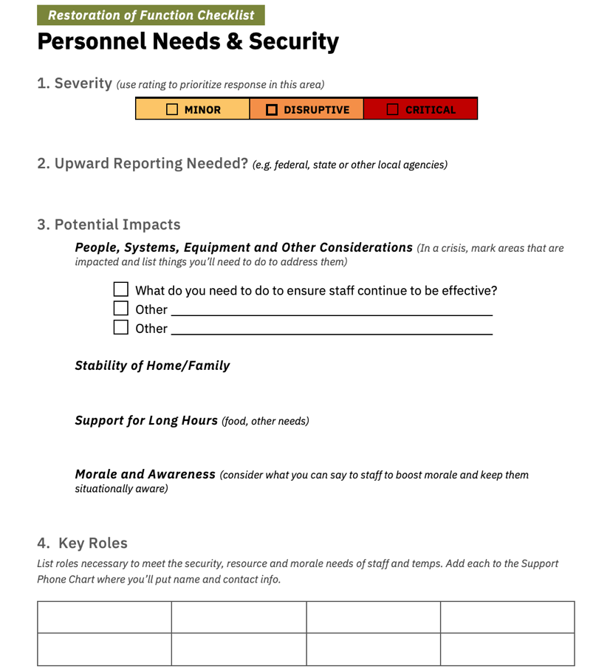
1. Severity – This is a space where you’ll consider how severe the impact of this incident will be on this functional area, and how that helps you prioritize response.
Estimating and recognizing severity will help with triage - determining which tasks you need to take on right away, and which you can push back till you have more time.
2. Upward Reporting Needs – If you think this incident and its impact need to be reported to the state election office, or higher level law enforcement, emergency management or other agencies, make a note here.
3. Potential Impacts – Here, you’ll list out major tasks, systems and equipment that fall under this function, as well as key actions you plan to take to ensure continuity or restore operations.
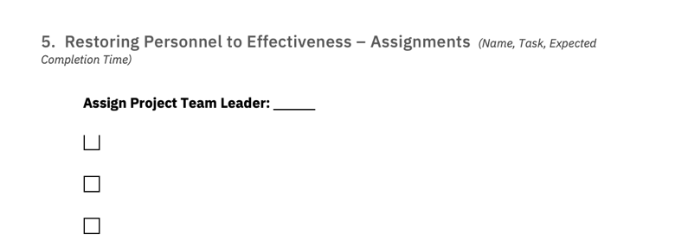
4. Key Roles – Here, you’ll list roles that need to be covered to ensure continuing operations in this area. Any functions here will be listed in the Support Team Contact chart, where you’ll fill in the name and contact information. (They’re not listed by name in the checklists because many checklists will share names, and you’d have to write contacts multiple times.
5. Assignments and Deadlines - You won’t complete this section in building out your Toolkit. This section is a worksheet to use in a crisis. This is where you and your core team will record key tasks, who is responsible and when you need them done.

Prioritizing Management Functions & Operations
As we’ve mentioned, the Restoration of Function checklists mirror the categories from the Incident Assessment checklist. We divided Section A, the main table of the Incident Assessment checklist, into two parts - management functions and functions related to election operations, and also set aside the Required Response checkboxes (for Troubleshooting and Communications).
We’ve done the same with the Restoration of Function checklists, separating Management and Elections checklists and Required Response checklists into their own sections of the Toolkit.
- That’s because as you plan for recovery, you must prioritize restoring management functions.
If senior people, the central facility or operations that support management are disrupted, no response can unfold until they are restored.
Calls made during the initial response prioritize restoration or replacement of these functions, the ones separated out on the Incident Assessment:
Senior Management and Succession
- Planning in case you or your key lieutenants are directly impacted, attacked or threatened or unable to work, including listing the line of succession if you as senior election official are incapacitated.
Central Facilities
- If the central facility is damaged, without power or evacuated
IT & Emergency Comms Networks
- If communications networks are attacked, slowed or unavailable

Personnel Needs & Security
- If the lives of election staff are disrupted, contingencies that can support them, get them back to work, maintain morale and assure their safety
Physical & Cybersecurity
- Ensuring security both when the incident itself puts the office under threat or attack, or if impacts of the incident undermine your standard security procedures.

Restoring Election Functions
The second column of the Incident Assessment checklist shows six categories of election operations. The RoF checklists for these election operations categories come after the management checklists in the Toolkit. These are the responsibilities of your office most visible to voters:
Voter Registration and other data entry
- Backup options if the VR system is unavailable, including both maintaining ongoing data entry and updating and the creation or use of lists or data to validate voters and ballots
Mail Ballots
- Contingencies if outbound mail, or the receiving and processing of returned ballots is compromised
In-Person Voting systems and resources
- If the preparation, delivery or security of voting machines, e-pollbooks and other in-person voting resources is compromised, how can you respond?
Poll Workers
- How to respond if your larger pool of election day or mail ballot processing workers become unavailable, or an incident prevents scheduled trainings or the handoff of manuals, keys and other needs
Polling Places and other facilities
- How to respond if polling places become unavailable or if an incident requires temporary or longer evacuation
Tabulation and Reporting
- How do you proceed if an incident threatens your ability to complete tabulation and publish results in a timely manner.

Managing Required Responses
Finally, the Toolkit has two checklists to remind you of important Emergency Response tasks that may not be “impacted” by the emergency, but must be handled effectively:
Investigative/Troubleshooting
- Building a team handle internal investigations of the causes of issues, whether due to technical problems, misunderstandings of procedures or technology, or tampering or another type of intentional incident.
- Note that criminal investigation should be handled by law enforcement, though you should be prepared to support and provide information.
Communications
- Ensuring that clear and appropriate information about incident recovery is provided to the public.
- Ensuring that the Core Team, Support Team and other partner agencies and personnel receive necessary and relevant information, regularly updated.

B. Exercise: Building Out the Restoration of Functions Checklists
In this exercise, you will think through your response to one crisis scenario and update relevant Restoration of Function checklists in the Toolkit to reflect your answers.

Review: Assessing the Functional Impact of an Incident
At the end of Section I-B, you assessed the functional impact of one of the crisis scenarios you had brainstormed. You marked up a sample Incident Assessment Form to show which functional areas of your office would be affected.
Refer back to that Assessment form and write down the incident you selected and the areas of your office you marked as being impacted by that incident:
Incident:

Functional Areas of Your Office Impacted by the Incident:

Building Out the Restoration of Function Checklists
We’re going to walk you through the steps of making a contingency plan from a Restoration of Function checklist. Each checklist in the Toolkit is a partially completed template. Every election office has a unique set of characteristics and challenges, so you’ll need to adapt the RoF checklists to your office’s operating environment.
- Let’s start with the first functional area you listed in the table above:
1) Open the Toolkit file to the relevant Restoration of Function checklist
- For instance, if your incident affected Polling Places, turn to that RoF checklist.
2) Consider the incident and your jurisdiction’s vulnerabilities.
- In our example, what facilities do you rely on, beyond your central office?
  - Edit the bullet points in “Section 3 – Potential Impacts” to list them out
- How were they affected by the incident? Power outage? A security incident that closed the building? What other ways could they be affected?
  - Add bullets for ways in which facilities might be affected.
- What is the potential scope of impact?
  - Can the impact be remediated quickly or is the facility out of commission?
Edit bullets to reflect the range of threats and vulnerabilities brought to mind by this incident, and generally for this functional area.
3) Looking at the boxes in section 3, does the text of these sections reflect the full range of responses needed to an out in this area?
That is, the text clearly doesn’t list out every step you might need to take, but would every step you would take fit under one of these headings.
- Using Polling Places and other facilities, do the responses shown – assessing facility damage, replacing facilities and communicating to voter and the public adequately reflect the range of responses you might make?
  - Does a remedy like “restoring power to a polling place with a generator” fit here? Maybe this checklist needs a section on “Rapid Remediation”
- Edit the checklist to reflect the full range of actions. You can change, add or delete text from the template or even add a new box or two.
4) Once you’ve edited the text to reflect the range of remedies, consider each box and list steps you might need to take to achieve restoration of function.
In our Polling place example, the boxes on your checklist might end up looking like this:

Facility Assessment
Pull in polling place staffer
Call school district facilities manager and park district manager (two largest sources of polling places); or email owner or contact of each polling place
Ask drop box retrieval team to visit polling places you’re unsure of.

Remediation:
Retrieve and install backup generator
Request that law enforcement provide security; or a facility sweep

Replacement:
Public buildings pre-identified as backup sites
Backup from wedding/event tent company; or provider of construction site
“box car-style” offices
Hauling company for transfer of voting equipment

Communications:
(Category stricken because you feel it will be adequately addressed elsewhere)
Your goal is not a comprehensive list of responses to every situation. That would be nearly impossible.
Instead, you want to have a good set of remedies, so that when you come together with your Core Team to develop a response to a specific crisis, some of the thinking is already done. You can think creatively and flexibly, using these steps as a starting point.

Building Out the Next Restoration of Function Checklist
This is the moment when we have to concede something you’ve probably been worried about. Developing a comprehensive Emergency Readiness Plan is not a work of 60 minutes.
To get here, you may already have put in more than 60 minutes. Later in this guide, we’ll talk about how to schedule time to complete the RoF checklists. But you’ve accomplished a lot already:

Congratulations! You’ve now done the work to understand the third tool in the Emergency Readiness Toolkit—the Restoration of Function checklists, and you’ve built one out. You’ll build the rest more quickly.

The RoF Checklists for “Required Responses” to a Crisis
As we’ve mentioned, there are two significant undertakings tasks in a crisis which sit outside the remediation and restoration efforts addressing specific office functions that have been compromised. These are Investigative / Troubleshooting efforts and Communications.

Investigative/Troubleshooting Efforts

Criminal investigations are beyond the scope of this guide. They should be handled by law enforcement, and election offices should provide information and support as requested.
When you’re faced with a problem of uncertain cause, such as an undiagnosed failure of the voting system during Logic & Accuracy testing, or a data issue that gives the wrong ballot style for some addresses but not others, you may need to mount an investigation into causes.
Since each investigation will have unique factors, we suggest limiting your Response checklist to these factors:
- Build an investigative team, including:
  - Someone with knowledge of the system involved
  - Someone who likes problem-solving
  - Someone with organizational skills to compile information and track theories to be tested and their outcomes.
- Set a timeline for meeting to compare ideas and coming back together to share new information.

Crisis Communications
Crisis communications is a topic in itself, beyond the scope of this guide. A crisis communications plan is an important part of emergency readiness. We suggest taking these steps to build out the Communications response:
- Ask your communications officer to develop a crisis comms plan.
- Consult guidance like the Crisis Communications Toolkit from the Elections Group
- Develop template statements that are ready to go in an emergency, maybe relying on resources like these Elections Group templates.
  - Templates should always hit some key themes:
    - You are taking strong action to remediate the problem
    - You have a plan for ensuring voters can vote safely and ballots can be counted securely and accurately.

IV | Support Team Contact List & Backup

Resource List
The Support Team Contact List and the Backup Supply List are straightforward resources. The Support Team Contact list compiles all those people and organizations that may be useful in an emergency. And the Backup Resource List gives locations or sources for items, systems and resources that you might need.
We’ll show and describe them briefly. More importantly, we’ll help you build them out.

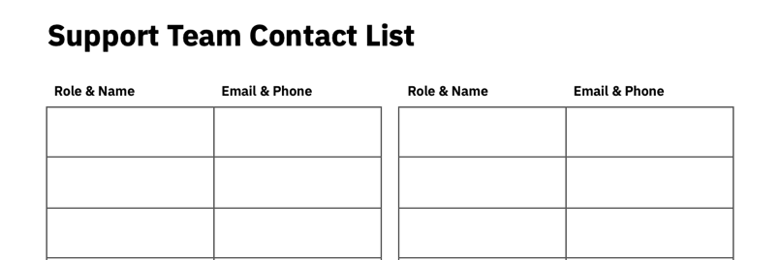
The Support Team Contact List
The Support Team List should be a comprehensive list of people you need or might need to rely on. We organize it by role to stress that you need someone to fill that role.
Here are some contacts you’ll likely want to include:

- Emergency Management director
- Law enforcement
- Fire department
- Phone company
- Electric company
- Internet provider
- Health department
- State election office

You will need to periodically confirm names and contact information for each role on the list. Don’t treat this as a rote task of checking the information, or assigning it to a junior staffer. Instead, seize the opportunity to strengthen the relationship and confirm that your support partners remain aware of your needs and willing to help when called on.

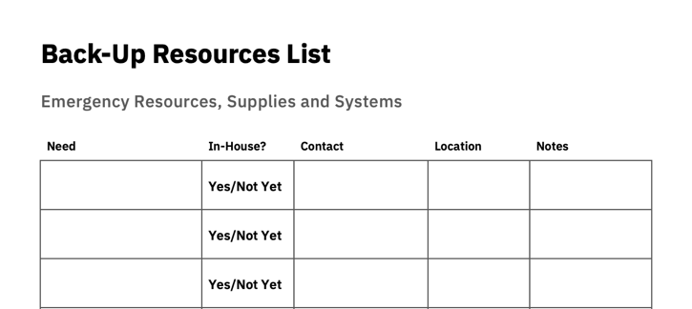
The Back-Up Resources List
The Back-Up Resources list is a list of things, rather than people, that you might need in a crisis. You might include items such as a power generator, backup laptops with preloaded access to the state voter file, or a ballot drop box in your warehouse.
This list has two purposes. First, the list includes location or source, ensuring that when a situation arises, you know to find each resource, whether internally or by contacting a support partner.
Second, having a formal list will prompt you to do better brainstorming about resources that could be useful. For instance, what is your backup if you lose a polling place? Have you always held in mind the possibility of setting up the kind of enclosed tent sometimes used for outdoor weddings and gatherings?
But maybe you never tracked down a source nor determined what would be necessary to set one up and provide electricity needed for voting machines? Put it on the list, initially listing it as “Not Yet Sourced.” Then, schedule a time to follow up and track down a supplier, cost estimates and recommendations for making it operational.

Exercise: Build Out the Support Team and Back-Up Resources Lists
To build out your Support Team Contacts and Backup Resources, go back to the Restoration of Function checklist that you built out in Chapter III.
For each remedy and response you listed, consider:
- Whose assistance would be necessary to get this done?
- What resources would be necessary?
- Write each answer in the appropriate list.
Don’t worry about the contact information or the location of resources yet. For now, just write down every person, role and resource you can think of.
- When you’ve listed all that you can, go back and fill in known details of phone numbers, email addresses, and the in-house locations or known providers of resources.

Congratulations! You’ve begun to build out the fourth and fifth tools in the Emergency Readiness Toolkit.

IV | Agenda for Full Readiness
To ensure that your office is ready for whatever might come at you, you still have a number of tasks. In keeping with our 60-minute theme, we suggest you avoid overburdening yourself. Take small, consistent steps by scheduling 60 minutes of time, maybe once a month.
- Schedule a time to continue building out your resources.
Date & Time:
- To fully build out the Toolkit, you need to run many of the scenarios that you brainstormed back in Chapter 1 through the steps we listed in the next three chapters of this guide.
  - Use the Incident Assessment Chart to determine which functional areas are impacted.
  - Take one Restoration of Function checklist relevant to this incident, and consider exactly what the vulnerabilities are in this functional area, and how you will address them
  - Considering your proposed remedies, add the names of people and resources needed to implement them to the Support Team and Backup Resource lists.
  - Schedule a time to do this again, until you have:
    - Built out all the Restoration of Function charts, and
    - Tested enough of your brainstorming scenarios that you feel confident.
- Add this date and time to your calendar.
- Schedule an hour to touch base with Core Team and Support Team Partners to build a relationship and go over your needs and expectations.
Date & Time:
- This can take the form of a 1-hour meeting with a group, or a series of 5- or 10- minute calls. Whatever makes the best use of your time and doesn’t overburden partners who have other pressing responsibilities.
- Add the date and time to your calendar.
- Schedule a time to consider budgeting for emergency preparedness.
Date & Time:
- Ask your budget officer or county liaison for a meeting to help you think about budgeting.
- Seek state guidance on grants, assistance or how to plan now for seeking reimbursement after an emergency.
- Add this date and time to your calendar.

- Schedule a time to take part in an emergency preparedness “Tabletop Exercise” (TTX).
Date & Time:
- Your state election office or an organization like the Committee for Safe & Secure Elections (CSSE) may schedule a TTX in your area.
- Many local offices have organized their own TTX, which may allow a wider set of Support Team Partners to participate who would not be able to travel elsewhere to take part.
  - You can seek TTX resources from your state or CSSE if you want to organize your own.
5. Schedule a time for revisiting the Toolkit and making sure everything is up-to-date.
Date & Time:
- You should probably do this at least every two years.
- Put this in your election task calendar.

Congratulations! You’re well on your way to full readiness for whatever crises come at you!

