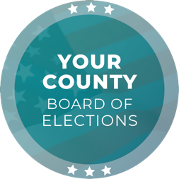
Media Contact
Contact Name
Contact Title
Phone Number
Email

FOR IMMEDIATE RELEASE

All Vote Centers are Now Open in [JURISDICTION] County:
Are You #ElectionReady?

[CITY], [STATE] (DATE) – This is the final weekend leading up to Election Day, and the [ELECTIONS OFFICE] is encouraging voters to be #ElectionReady for the [YEAR] [ELECTION NAME] Election. Voters in [JURISDICTION] County have several voting options and can avoid lines and delays by casting their ballot early.

The voter registration deadline was [DAY], [DATE]. Eligible voters who missed this deadline can still conditionally register to vote in person until Election Day. For more information on same-day voter registration, visit [WEBSITE].

Vote-by-mail ballots were placed in the USPS mail stream starting on [DATE]. Voters who signed up to receive a vote-by-mail ballot should have received theirs by now. Voters may also request a replacement ballot by visiting [WEBSITE]. To track the status of a vote-by-mail ballot, visit [WEBSITE].

Voters have several options to return their ballot: By regular mail, ballot drop box, or polling place. For ballot drop box locations and hours, visit [WEBSITE]. Voters may also drop off a ballot at any polling place during voting hours; for polling place locations and hours, visit [WEBSITE].

All Vote Centers are now open for in-person voting in [JURISDICTION] County, as of [DAY], [DATE]. For locations and hours, visit [WEBSITE].

For any questions, please email [EMAIL ADDRESS] or call [PHONE NUMBER].

Quote by [CHIEF ELECTION OFFICIAL NAME], [CHIEF ELECTION OFFICIAL TITLE]:
“In the two weeks leading up to Election Day, voters have multiple ways to ensure they are ready to vote and have their voices heard. My team and I are working diligently to ensure the success of the [YEAR] [ELECTION NAME] Election by providing convenient and safe voting options.”

###

The [ELECTIONS OFFICE] is responsible for conducting elections in the County of [JURISDICTION] with [NUMBER] registered voters. As a local election office, the [ELECTIONS OFFICE] manages the processing of vote-by-mail ballots, recruitment and training of election workers, in-person voting operations, and certification of elections.

