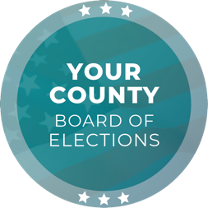
Media Contact
Contact Name
Contact Title
Phone Number
Email

FOR IMMEDIATE RELEASE

Two Weeks to Election Day: Are You #ElectionReady in [JURISDICTION] County?

[CITY], [STATE] (DATE) – Election Day is only two weeks away, and the [ELECTIONS OFFICE] would like to encourage voters to be #ElectionReady for the [DATE] [ELECTION NAME] Election. Voters in [JURISDICTION] County have several voting options and can avoid lines and delays by voting early.

The voter registration deadline passed yesterday on [DAY], [DATE]. Eligible voters who missed the deadline can still conditionally register to vote in person, starting tomorrow until Election Day. For more information on same-day voter registration, visit [WEBSITE].

Vote-by-mail ballots were placed in the USPS mail stream starting on [DATE]. Voters who signed up to receive a vote-by-mail ballot should have received theirs by now. Voters may also request a replacement ballot by visiting [WEBSITE]. To track the status of a vote-by-mail ballot, visit [WEBSITE].

Voters have several options to return their ballot: By regular mail, ballot drop box, or polling place. For ballot drop box locations and hours, visit [WEBSITE]. Voters may also drop off a ballot at any polling place during voting hours; for polling place locations and hours, visit [WEBSITE].

Select vote centers will open for in-person voting in [JURISDICTION] County on [DAY], [DATE]. All Vote Centers will open on [DAY], [DATE]. For vote center locations and hours, visit [WEBSITE].

For any questions, please email [EMAIL ADDRESS] or call [PHONE NUMBER].

Quote by [CHIEF ELECTION OFFICIAL NAME], [CHIEF ELECTION OFFICIAL TITLE]:
“In the two weeks leading up to Election Day, voters have multiple ways to ensure they are ready to vote and have their voices heard. My team and I are working diligently to ensure the success of the [DATE], [YEAR] [ELECTION NAME] Election by providing convenient and safe voting options.”

###

The [ELECTIONS OFFICE] is responsible for conducting elections in the County of [JURISDICTION] with [NUMBER] registered voters. As a local election office, the [ELECTIONS OFFICE] manages the processing of vote-by-mail ballots, recruitment and training of election workers, in-person voting operations, and certification of elections.

