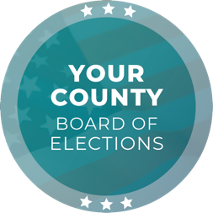
Media Contact
Contact Name
Contact Title
Phone Number
Email

FOR IMMEDIATE RELEASE

[YEAR] [ELECTION NAME] Ballots have been Placed in the USPS Mail Stream

[CITY], [STATE] (DATE) – The [ELECTIONS OFFICE] has placed ballots in the USPS mail stream for the [ELECTION NAME] Election. Information regarding ballot content is included in the State and County Voter Information Guide; voters who have not received a guide in the mail may view the guide online by visiting [WEBSITE]. Additionally, [XX] of 24/7 ballot drop boxes have been opened for the [ELECTION NAME] Election and will remain open until [TIME] p.m. on Election Day, [DATE], [YEAR].

Voters who signed up to receive a vote-by-mail ballot will receive their ballot in the coming days. Voters may also request a vote-by-mail ballot by visiting [WEBSITE] and can track the status of a vote-by-mail ballot by visiting [WEBSITE].

Voters may return their voted vote-by-mail ballots utilizing one of the following methods:

- Regular mail
- 24/7 ballot drop box
- Polling place

Ballot drop box and polling place locations and hours can be found online at [WEBSITE].

For any questions, please email [EMAIL ADDRESS] or call [PHONE NUMBER].

Quote by [CHIEF ELECTION OFFICIAL NAME], [CHIEF ELECTION OFFICIAL TITLE]:
“With ballots mailed out, voters now have the opportunity to make their voices heard and play a role in shaping their community. My office is committed to assisting voters and providing a positive voter experience.”

###

The [ELECTIONS OFFICE] is responsible for conducting elections in the County of [JURISDICTION] with [NUMBER] registered voters. As a local election office, the [ELECTIONS OFFICE] manages the processing of vote-by-mail ballots, recruitment and training of election workers, in-person voting operations, and certification of elections.

