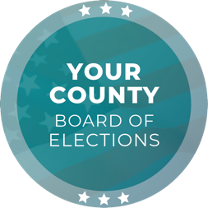
Media Contact
Contact Name
Contact Title
Phone Number
Email

FOR IMMEDIATE RELEASE

[ELECTIONS OFFICE] is Recruiting Applicants for [YEAR] [ELECTION NAME] Election to Address Critical Shortage of Poll Workers

[CITY], [STATE] (DATE) – [ELECTIONS OFFICE] is urgently recruiting poll workers for the upcoming [YEAR] [ELECTION NAME] election season.

For the [ELECTION NAME] election, [NUMBER] of bipartisan election workers are needed to ensure polling locations, processing and counting operations run smoothly. Positions are paid between [$XX.XX] and [$XX.XX] per hour and include a variety of roles, including voter support, registration and ballot processing.

All poll workers receive paid training for their respective roles. Length of assignments range from one day (Election Day) to a few weeks, depending on availability and need.

“Election workers serve an important role in ensuring [JURISDICTION] elections are safe, secure and accurate. Those who participate earn invaluable work experience, gain a wealth of knowledge about the electoral process, and get to contribute directly to their community, all while sustaining the backbone of democracy,” [CHIEF ELECTION OFFICIAL TITLE] [CHIEF ELECTION OFFICIAL NAME] said.

Those interested in working the [YEAR] [ELECTION NAME] election are encouraged to visit [WEBSITE] to submit an application. Applicants must meet the following requirements:

- Be a United States citizen
- Be registered to vote in [STATE OR JURISDICTION]
- Pass a background check
- Complete the onboarding process, including paperwork, orientation and training
- Be able to work all assigned dates and hours
- Have never been convicted of any election offense or fraud
- Not have a family member (to the 2nd degree) on the ballot

The deadline to apply to become a poll worker is [DAY], [DATE]. For questions, email [EMAIL] or call [ELECTIONS OFFICE] at [PHONE NUMBER].

###

The [ELECTIONS OFFICE] is responsible for conducting elections in the County of [JURISDICTION] with [NUMBER] registered voters. As a local election office, the [ELECTIONS OFFICE] manages the processing of vote-by-mail ballots, recruitment and training of election workers, in-person voting operations, and certification of elections.

