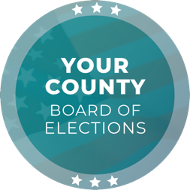
Media Contact
Contact Name
Contact Title
Phone Number
Email

FOR IMMEDIATE RELEASE

[ELECTIONS OFFICE] Asks Community Partners to Help Register Voters on National Voter Registration Day

[CITY], [STATE] (DATE) – To celebrate National Voter Registration Day, [ELECTIONS OFFICE] is encouraging community partners to help register eligible voters prior to the voter registration deadline to participate in the [DATE], [YEAR] [ELECTION NAME] Election.

The voter registration deadline is [DATE], [YEAR].

To register to vote, eligible voters can:

- Use any official voter registration form to register online, by mail, fax, or in person
- Request a paper voter registration form be mailed to you. Email your request to [EMAIL ADDRESS]

Individuals who are 17 years of age who will turn 18 by Election Day will be eligible to cast a ballot in this election and may pre-register to vote

Registered voters are highly encouraged to check their registration record to ensure that the correct mailing address is on file, especially if you are expecting a vote-by-mail ballot to be delivered. Voter registration records can be checked online at [WEBSITE] or by calling [PHONE NUMBER].

Voters needing additional assistance may visit [WEBSITE], email [EMAIL ADDRESS], or call [PHONE NUMBER]. Voters who miss the voter registration deadline may register through same-day voter registration by registering in person at the [ELECTION OFFICE] between [Date] to Election Day, [DATE].

“Approximately [NUMBER] voters are registered in [JURISDICTION] County and there has been a historical increase in the number of voters as Election Day nears. To avoid potential delays to increased processing times, eligible voters who plan to cast a ballot this election are encouraged to register early,” [CHIEF ELECTION OFFICIAL TITLE] [CHIEF ELECTION OFFICIAL NAME] said.

###

The [ELECTIONS OFFICE] is responsible for conducting elections in the County of [JURISDICTION] with [NUMBER] registered voters. As a local election office, the [ELECTIONS OFFICE] manages the processing of vote-by-mail ballots, recruitment and training of election workers, in-person voting operations, and certification of elections.

