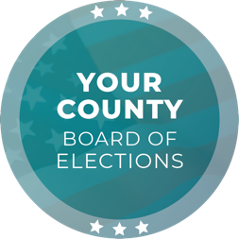
Media Contact
Contact Name
Contact Title
Phone Number
Email

FOR IMMEDIATE RELEASE

[ELECTIONS OFFICE] Certifies [DATE], [YEAR] [ELECTION NAME] Election Results

[CITY], [STATE] (DATE) – [CHIEF ELECTION OFFICIAL TITLE] [CHIEF ELECTION OFFICIAL NAME] today certified the official election results of the [DATE], [YEAR] [ELECTION NAME] Election for [JURISDICTION] County. To view the official election results, visit [WEBSITE].

Total voter turnout for the election was [##] percent. Of voters that cast a ballot, [##.X] percent cast a vote-by-mail ballot, and [##.#] percent cast an in-person ballot at one of ## in-person voting locations throughout the county.

Prior to certification, two audits were completed to verify the results of the election. Both audits confirmed that the results of the election were correct. Details on the audits can be found at [WEBSITE].

Additionally, [ELECTIONS OFFICE] confirmed that the state-certified voting system software had not been modified during the election.

Quote by [CHIEF ELECTION OFFICIAL NAME], [CHIEF ELECTION OFFICIAL TITLE]:
“I could not be more pleased with the level of focus, accuracy, and integrity that my team demonstrated. We worked diligently to serve the voters of [JURISDICTION] County, providing them with equal access to the election process, protecting the integrity of their votes, and maintaining a transparent, accurate, and fair elections process.”

###

The [ELECTIONS OFFICE] is responsible for conducting elections in the County of [JURISDICTION] with [NUMBER] registered voters. As a local election office, the [ELECTIONS OFFICE] manages the processing of vote-by-mail ballots, recruitment and training of election workers, in-person voting operations, and certification of elections.

