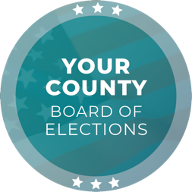
Media Contact
Contact Name
Contact Title
Phone Number
Email

FOR IMMEDIATE RELEASE

Last Chance to Vote: Today is Election Day
Polls Close at [TIME] p.m., Vote Early to Avoid Lines

[CITY], [STATE] (DATE) – Tuesday, is Election Day and is the last chance for voters to participate in the [DATE], [YEAR] [ELECTION NAME] Election. Several voting options are available, and voters must cast their ballot by [TIME] p.m. tonight.

The voter registration deadline was [DATE]. Eligible voters who missed this deadline can still conditionally register to vote in person until [TIME] p.m. today. For more information on same-day voter registration, visit [WEBSITE].

Vote-by-mail ballots were mailed out during the [FIRST/SECOND,ETC] week of [MONTH], and most voters who signed up to receive a vote-by-mail ballot should have received theirs by now. If not, voters may request a replacement ballot in person until [TIME] p.m. today.

Voters have several options to return their ballot: By regular mail, ballot drop box, or polling place. Voters may drop off a ballot at any polling place or ballot drop box until [TIME] p.m.; for polling place and ballot drop box locations, visit [WEBSITE].

All vote centers are now open for in-person voting in [JURISDICTION] County. All voters in line before [TIME] p.m. will have an opportunity to cast a ballot. For vote center locations, visit [WEBSITE].

For any questions, please call [PHONE NUMBER].

Quote by [CHIEF ELECTION OFFICIAL NAME], [CHIEF ELECTION OFFICIAL TITLE]:
“My team and I are ready for Election Day after months of hard work, dedication, and preparation. We encourage all eligible voters to take advantage of the voting options available in [JURISDICTION] County and cast their ballot by [TIME] p.m. tonight.”

###

The [ELECTIONS OFFICE] is responsible for conducting elections in the County of [JURISDICTION] with [NUMBER] registered voters. As a local election office, the [ELECTIONS OFFICE] manages the processing of vote-by-mail ballots, recruitment and training of election workers, in-person voting operations, and certification of elections.

